**What is Software Testing?**

<https://www.youtube.com/watch?v=54dbm7DMNso>

**What is Software Testing?**

Software testing is the process in which the features and functionalities of a product are evaluated with the intent of locating all defects and errors within the product.

**Why is Software Testing important?**

Software testing helps to identify the defects and errors that were made during the development phases of a product. Software testing enables developers to produce high quality products for their users that are free from defects in the features, functionalities and process flows of the product.

**What is a Software Tester?**

A software tester is a person that uses and evaluates a product to identify the defects and errors within the product.

**What is Crowdtesting?**

<https://www.youtube.com/watch?v=9ixfsncbt9U>

Crowdtesting is when a group of people test the same product in real world scenarios to provide insights and feedback about the product.

Millions of people across the globe can download the same app and have entirely unique experiences. There are hundreds of variables that could lead one person to have a positive user experience where another would have a less than ideal one. Differences such as devices and software, physical locations, user demographics, and level of tech savviness could all lend to wildly different digital experiences.

Traditional testing methodologies are no longer sufficient in today's ever changing, ever growing, digital landscape. Even the most advanced in-house QA departments are ultimately restricted in what they are able to test, and can not account for real-world complexities users face on a daily basis. The solution? Crowdtesting.

uTest is the pioneer and leader of In-the-Wild Crowdtesting since 2007. At uTest, we believe that only real people, using real devices, in real locations, under real world scenarios, are able to provide our customers with the authentic user insights required to build the very best digital experiences. Everyday across the globe uTest testers are paid to provide digital testing, payment testing, and omnichannel feedback, to the world’s leading brands. Giving invaluable visibility into how their technology works in the hands of their users.

The uTest Community is made up of people from all over the world with distinct backgrounds, interests, skills, and professions. The diversity of our testers is just one of the many reasons uTest is so successful.

uTest has specialized in Crowdtesting since 2007.

**What things can I learn and practice?**

You will learn and practice the following things in the uTest Academy courses and practice test cycles:

* Basic essentials of uTest
* Different types of testing at uTest
* How to be a high quality tester
* How to accept or decline a test cycle
* How to find a bug and submit an issue report
* How to claim a testing slot
* How to complete a test case
* How to capture screenshots and videos
* How to record computer and device logs
* How to communicate with the community and Test Team Lead in chat

**What practice test cycles are available?**

* Introduction to testing - for new uTest members
* Computers testing - for testing on Desktop & Laptop machines
* Mobile device testing - for testing on Mobile & Tablets devices
* Charles proxy testing - for decrypting website traffic on computers and mobile devices
* Academy Challenge - for competing with other new Academy testers
* Academy All Stars - Invitation only - for the best Academy testers

**Helpful Definitions**

Here is a list of the most common terminology and acronyms which used on uTest.com and within uTest projects. More details can be found on the Academy page.

| **Terms** | **Description** |
| --- | --- |
| **Testing Team:** | |
| Client or Customer | A company that has engaged Applause and the uTest Community to test their product. |
| TTL | The Test Team Lead (TTL) is the primary point of contact for testers. The TTL helps testers within test cycles and reviews all submitted bug reports and test cases, etc. |
| TE | The Test Engineer (TE) builds the test cycle, assembles the testing team and is responsible for the overall execution of the test cycle. Also, the TE is responsible for marshalling the test team through completion of the test cycle achieving the goals of the request. |
| TSM | Test Architect (TA) title has been replaced by Testing Services Manager (TSM). The TSM works directly with the client. They manage a team of TTLs and TEs to identify and provide appropriate solutions for the client’s testing, feedback or research needs. |
| SDM | The Solution Delivery Manager (SDM) is the customer’s primary point of contact, and works with the customer directly. |
| CM | The Community Manager (CM) are members of the Community Management Team. The Community Management Team's goal is to help our global community to learn how to be excellent testers, to get opportunities for paid projects, and to connect with fellow testers across the community and the globe. Meet the uTest Community Management team from [here](https://www.utest.com/about-us). |
| CE | Community Engineers are members who work closely with the CM team and help with their tasks and responsibility. |
| DT | The Dedicated Testers’ function is to provide the team with speed, specialized expertise, and quality control. This role differs from the traditional role of our community testers and they are supposed to have a singular focus and dive deep. These testers should be seen as experts by their community peers and help support the TTL in chat management as an expert. Testers who have a strong history of quality work are more likely to be approached by a TSM/TE to ask about becoming a DT. |
| ACE | Accessibility Expert leads numerous audits simultaneously, mentors other members of the team and presents final audit results to clients. |
| ACA | Accessibility Auditor participates in audits by reporting accessibility bugs and completing test cases. They may still require some direction and assistance from other members of the team when testing and writing bug reports. |
| TCW | Test Case Writer responsible for writing test cases and ensuring each test case has detailed, clear and easy to follow steps and expected results as well as verifying that the documentation and test cases provided by the customer are valid and can be used and making any necessary adjustments |
| **Test Cycle Terms:** | |
| Project Or Test Cycle | One specific test of a company's product. Each individual test cycle includes numerous testers and can vary greatly from other test cycles depending on the cycle setting, type, etc. In the test cycle, testers must carefully follow the instructions in the test cycle's overview to find bugs on the in scope product, execute test cases, submit reviews, or conduct usability studies, if available. |
| Test Case | A Test Case is a set of predefined steps that must be followed and executed by a tester in order to test specific features and functionalities of a product, such as exercising a particular program path or verifying compliance with a specific requirement. |
| Slot | A slot is a reserved position within a test cycle for a tester with specific requirements such as location, device, OS, etc. A slot may or may not be linked to test cases, if a slot is not linked to a test case it is referred to as an Exploratory slot which means a tester can freely test the product and report bugs that are found and are within the in scope areas. |
| Issue/Bug report | Is a written summary of a specific error or defect (bug) in a product's features or functionality. A bug report should contain all the required information to understand, reproduce, and fix the bug. |
| **Testing Types:** | |
| Fn - Functional | Testing the features/functionality of a product with the intent of locating issues. |
| Ln - Localization | Verify the quality of a product in terms of a particular target culture/locale. |
| Ux - Usability | Measures how easy to use and user-friendly a product is by testing it with real users. |
| Security Testing | A process intended to reveal flaws in the security mechanisms of a product. |
| Automation Testing | Using an automation testing tool to execute repetitive testing steps, which may be difficult to perform manually. |
| PT / PI Payment Testing / Payment Instruments | At its core, Payment Testing is any test that requires the use of a payment instrument to complete. |
| AC - Accessibility | Ensures that a product is usable by people with disabilities like hearing, color blindness, old age, and other disadvantaged groups. |
| API Testing: Validates Application Programming Interfaces (APIs). | The purpose of API Testing is to check the functionality, reliability, performance, and security of the programming interfaces. |
| Voice testing | Testing voice-enabled products with native speakers. It combines functional testing, dialogue verification, usability testing, and payment testing to help companies deliver voice experiences that foster ongoing customer engagement and satisfaction. |
| Bug Hunt Testing | This is a robust exploratory test. The goal of this kind of testing is to only find out a specific bug or a specific bug on a specific device or specific type of bug that occurs within the testing scope. Testers invited to this cycle should carefully read and understand the overview and the requirements and they must avoid reporting issues that are not in scope. |
| On-site testing | Visiting a physical location to evaluate the quality of the service and collect feedback. |
| Live Testing | Testing at a specific time, testers must perform testing at that time, they cannot be late or test earlier. |
| ET - Exploratory Testing | Exploratory Testing is a simultaneous activity of learning, test design, and test execution. In other words, the tester is designing their tests and executing them at the same time. As an exploratory tester, your next action (the next test) is influenced by your previous actions, your observations of the product’s behavior, and your own thought process. The key aspect of Exploratory Testing is not the test technique being used or the product being tested, but the skills and experience of individual testers. |
| **uTest Terms:** | |
| SRS - Special Requirement Survey | Is a tool that is widely used by Testing Services and Community Management to recruit testers for test cycles where data points are needed that the platform doesn’t capture yet. |
| KI - Known Issue | Known Issues are the issues that are already been found in previous Test Cycles or the issues that the customer already knows about. Known issues are helpful to prevent duplicate submissions, and in order to avoid rejections, testers should always check them before starting testing. The known issues can be added in the Cycle in sort of a spreadsheet or you can recognize them by seeing a blue “bookmark” tag next to the issue to indicate that this is a Known Issue in the title column of the issues page. |
| BFV - Bug Fix Verification | Is a process of verifying if a reported bug has been fixed when a fix or a new build for the product is released. Applause allows customers to run a re-test once a new build with fixes for those bugs is available, effectively verifying that the bug has been fixed. |
| NDA - Non Disclosure Agreement | Which is a binding contract between Tester and Applause App Quality, and by signing the NDA the tester agrees not to disclose any information covered by the agreement. Typically used to protect any type of confidential and proprietary information. |
| IR - Info Request | More information is requested on a bug report or test case, or a tester is required to fix the bug report or test case. |
| Environment | Refers to device, OS, OS version, browser, or any specific setup that is used for testing. |
| Triage/Triaging | A process of reviewing a bug report or test case and then sending an info request or recommending the bug report or the test case for approval or rejection. |
| Placeholder | A placeholder is a submitted bug report without complete information or required attachments for the purpose of reserving the position of the report and later on edit and completing the report or changing it to a different bug. |
| Reproduction | Is the process of recreating a bug by following the action performed steps in a bug report. |
| Turnaround Time | This is the time limit when testing work should be submitted. For example, a slot or test case with a turnaround time of 6 hours should be submitted within 6 hours after claiming the slot or test case. |
| **Bug Rejection Types:** | |
| WAD - Working As Designed | Work as designed is a rejection where the reported issue is working as designed, meaning that the behavior is exactly how the product is designed to work. |
| DUP - Duplicate issue | A duplicate rejection is a rejection where the bug reported is already reported by another tester or is a Known Issue that is added to the cycle. |
| OOS - Out Of Scope | An Out of Scope rejection is a rejection where the reported bug is not in the scope of the testing product, for example only certain areas of the website are being tested in the cycle and any other areas should not be tested, reporting a bug that is found in one of these areas that are not in the scope of the cycle will be categorized as Out of Scope, the same case applies if the issue was found in a product that was not being tested like an external website. |
| DNFI - Did Not Follow Instructions | Can be used when the tester ignored clear instructions which affected the outcome or made the report unusable. |
| INF - Need more info | A tester did not provide the requested information to the bug report when an info request was sent. |
| Other | All rejection reasons should be covered by using the above ones. In case the customer has a different reason for rejection, they might use Other. |
| **Bug Approval Types:** | |
| Somewhat Valuable | The bug has some impact on the product and has some value to the customer. |
| Very Valuable | The bug has a significant impact on the product and very valuable to the customer. |
| Exceptionally Valuable | The bug has a critical impact on the product and must be fixed. These bugs bring exceptional value to the customer. |
| WNF - Won't Fix | The bug is valid and approved but the customer is not interested in it or not planning to fix it. |
| **Ratings:** | |
| G | Gold |
| S | Silver |
| B | Bronze |
| P | Proven |
| R | Rated |
| U | Unrated |
| **Badges:** | |
| U (blue orb in top right of profile pic) | uTest Employee |
| M (orange “M” orb in top right of profile pic) | Moderator |
| TTL | Test Team Lead for uTest cycles |
| **Testing:** | |
| SDLC | Software Development Lifecycle is a process followed for a software project, within a software organization. It consists of a detailed plan describing how to develop, maintain, replace and alter or enhance specific software. The life cycle defines a methodology for improving the quality of software and the overall development process |
| STLC | Software Testing Life Cycle |
| QA | Quality Assurance |
| SUT | System Under Test |
| SPA | Single Page Application |
| BAT | Business Analysis Testing |
| API | Application Programming Interface |
| TF | TestFlight |
| BTS | Bug Tracking System |
| UAT | User Acceptance Testing (aka Beta Testing or End User Testing) |
| RAD (model) | Rapid Application Development |
| ISTQB | International Software Testing Qualifications Board |
| SDET | Software Development Engineer in Test |
| BBST | Black Box Software Testing |
| UX bug | Usability Bug |
| UI bug | User Interface Bug |
| AUT | Application Under Test |
| SIT | System Integration Testing |
| CMS | Content Management System |
| **Networks and Protocols** | |
| FTP | File Transfer Protocol |
| HTML | Hyper Text Markup Language |
| HTTPS | Secure Hypertext Transfer Protocol |
| VPN | Virtual private network |
| E2E | End to End |
| IP | Internet Protocol |
| **IT, Developer and Programming** | |
| OS | Operating System |
| URL | Uniform Resource Locator |
| WWW | World Wide Web |
| IE | Internet Explorer |
| XML | Extensible Markup Language |
| AWS | Amazon Web Services |
| VM | Virtual Machine |
| SEO | Search Engine Optimization |
| SDK | Software Development Kit |
| I/O | Input & Output |
| IDE | Integrated Development Environment |
| **Miscellaneous:** | |
| SMB | Small Medium Business |
| GUI | Graphical User Interface |
| ROI | Return on Investment |
| AI | Artificial Intelligence |
| POS | Point Of Sale |
| CTA | Call To Action |
| PLP | Product listing page |
| PDP | Product detail page |
| STB | Set-top box |
| PIP | Picture In Picture |
| CC | Closed Captions |
| VOD | Video On Demand |
| CTV | Connected TV |
| OTP | One Time Password |
| MFA | Multi-Factor Authentication |
| 2FA | Two-Factor Authentication |
| SSO | Single Sign ON |
| CVV / CVC / CSC / CVN | Card Verification Value / Card Verification Code / Card Security Code / Card Verification Number |
| PM | Private Message |
| FAQ | Frequently Asked Question |
| DMCA | Digital Millennium Copyright Act |

**What is Testing?**

[**https://www.youtube.com/watch?v=HwNBNQS4hsc**](https://www.youtube.com/watch?v=HwNBNQS4hsc)

**What is Testing?**

Testing is the process of evaluating a product to identify any gaps, errors, improvements, or missing requirements in contrast to the actual requirements.

The product is not limited to software; it can be hardware or a physical service too.

**Why is Testing important?**

Testing has many benefits. Here are some of them:

* **Product Quality:** High quality is an essential requirement for any product. Testing ensures delivery of a quality product to customers.
* **Customer Satisfaction:** The product must meet the customer needs. Testing also ensures that as well.
* **Security:** People are looking for trusted products on which they can rely. Testing helps remove vulnerabilities from a product and make it more secure beforehand.
* **Cost-Effectiveness:** Testing helps identify issues early, and it costs less time and money to fix them. The same can be very expensive in the future or in the later stages of development.

**Types of Testing in uTest**

There are many types of testing methods and approaches. Here we will only discuss the types of testing we conduct on uTest.

* **Functional Testing:** Testing the features/functionality of a product with the intent of locating issues.
  + **Exploratory Testing:** Exploratory Testing allows testers to use their knowledge and experience to identify areas of the product that may be vulnerable to potential failure. This type of testing also allows testers to think outside the box and try different approaches when testing the product.
  + **Regression Testing:** Is a type of software testing that seeks to verify that changes or modifications to a system do not result in unintended outcomes. It is typically done after changes have been made to make sure the system still works as it is supposed to.
  + **Smoke Testing:** Smoke tests ensure that the core functions of the system still work correctly by running a few basic tests. Regression testing is more in-depth, testing all the features of the system to make sure that all the changes made have not caused any unintended effects.
* **Usability Testing:** Measures how easy to use and user-friendly a product is by testing it with real users. We have a dedicated track on Usability testing [here](https://www.utest.com/academy/tracks/29).
* **Localization Testing:** Verify the quality of a product in terms of a particular target culture/locale.
* **Security Testing:** A process intended to reveal flaws in the security mechanisms of a product.
* **Automation Testing:** Using an automation testing tool to execute repetitive testing steps, which may be difficult to perform manually.
* **Payment Testing:** At its core, Payment Testing is any test that requires the use of a payment instrument to complete. We have a dedicated track for it [here](https://www.utest.com/academy/tracks/3).
* **Accessibility Testing:** Ensures that a product is usable by people with disabilities like hearing, color blindness, old age, and other disadvantaged groups.
* **API Testing:** Validates Application Programming Interfaces (APIs). The purpose of API Testing is to check the functionality, reliability, performance, and security of the programming interfaces. It is one of the most challenging testing types at uTest, and we have a dedicated track for it [here](https://www.utest.com/academy/tracks/28/courses/what-is-api).
* **Voice testing:** Testing voice-enabled products with native speakers. It combines functional testing, dialogue verification, usability testing, and payment testing to help companies deliver voice experiences that foster ongoing customer engagement and satisfaction. Learn more helpful details [here.](https://www.utest.com/articles/exploring-your-tech-voice-assistants)
* **Bug Hunt Testing:** This is a robust exploratory test. The goal of this kind of testing is to only find out a specific bug or a specific bug on a specific device or specific type of bug occurs within the testing scope. Testers invited to this cycle should carefully read and understand the overview and the requirements and they must avoid reporting issues that are not in scope.

**Examples of bug hunt cycles**:

* + A Bug hunt cycle to catch a crash bug when playing a specific game or using an App
  + A Bug hunt cycle to find out if testers with a specific device are able to reproduce specific bug(s), etc.
  + A Bug hunt cycle to catch a freeze/slow loading when opening specific page or section or playing a game
  + A Bug hunt cycle to find that the App freeze of more than 60 seconds when launching the app after first-time installation or app update

In this kind of cycle, you should always avoid testing other areas, as there is a too specific requirement, and the customer is only interested in this thing, thus reporting out of the testing scope will be rejected as OOS or DNFI which will have a big negative impact on your tester rating.

* **On-site testing:** Visiting a physical location to evaluate the quality of the service and collect feedback. Learn more [here](https://www.utest.com/articles/on-site-testing-another-way-to-earn-with-utest).

**What is a Bug (Issue)?**

[**https://www.youtube.com/watch?v=HylqecDbYEI**](https://www.youtube.com/watch?v=HylqecDbYEI)

**What is a bug or an issue?**

An issue or bug is an error, flaw or fault in a product (Like: Website, App etc) that causes it to produce an incorrect or unexpected result, or to behave in unintended ways.

Put simply, a bug is something that isn't working correctly in an application or website.

**Issue types**

At uTest we categorize issues into five different types: **Functional, Visual, Content, Performance, Crash**

We will discuss each type in detail now.

**1. Functional**

Functional issues are workflow failures where something in the test application did not work as it was designed to. These issues produce an unexpected or illogical application behavior where the end result differs from the expected result.

**Examples:**

* Broken page links
* Search and filters return incorrect results
* Button does not respond when clicked

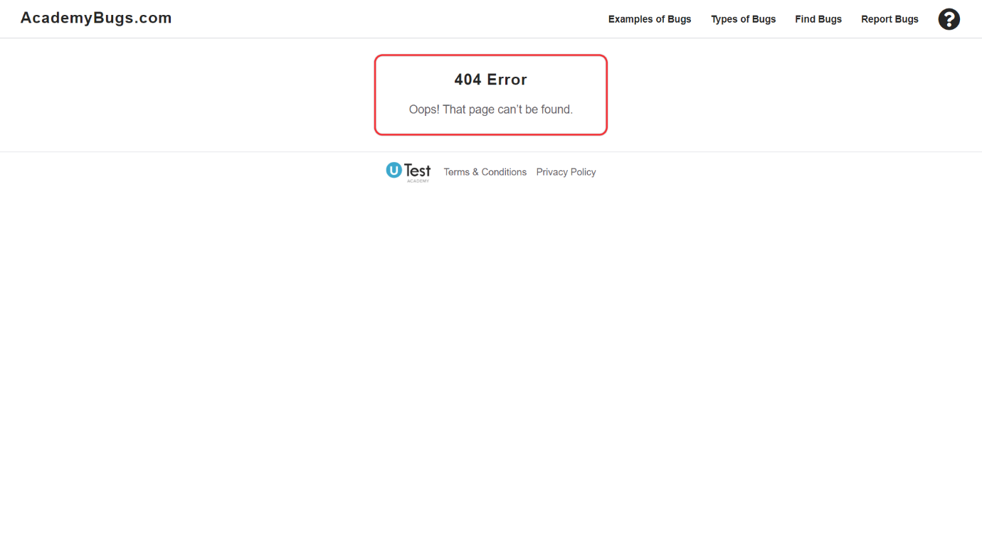

**2. Visual**

Visual issues affect the layout and cause user interface distortion such as missing elements or images on a page.

**Examples:**

* Page elements or content is misaligned
* Content does not fit the area it is in
* Inconsistent colors on a link, button or menu
* Picture is missing

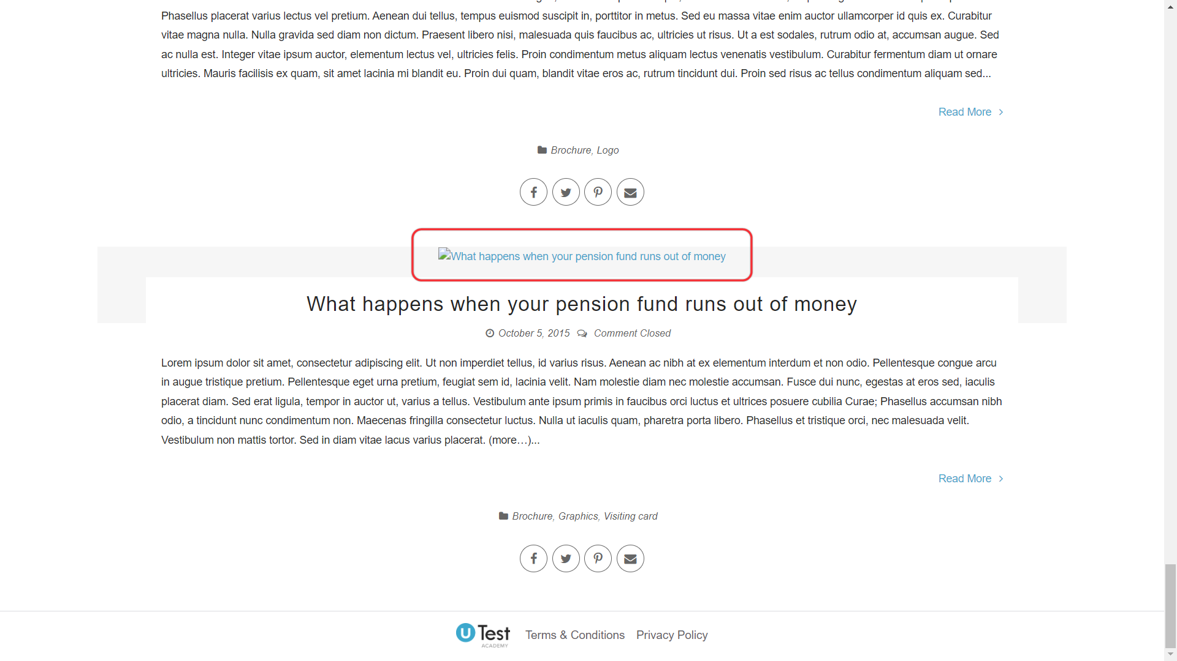

**3. Content**

Content issues affect the text of a page, such as spelling, grammar and localization errors.

**Examples:**

* Localization issues where the wrong word is used in page translations
* Spelling and capitalization errors such as uTEsT
* Punctuation is used incorrectly in text ( , . : ; ' " )

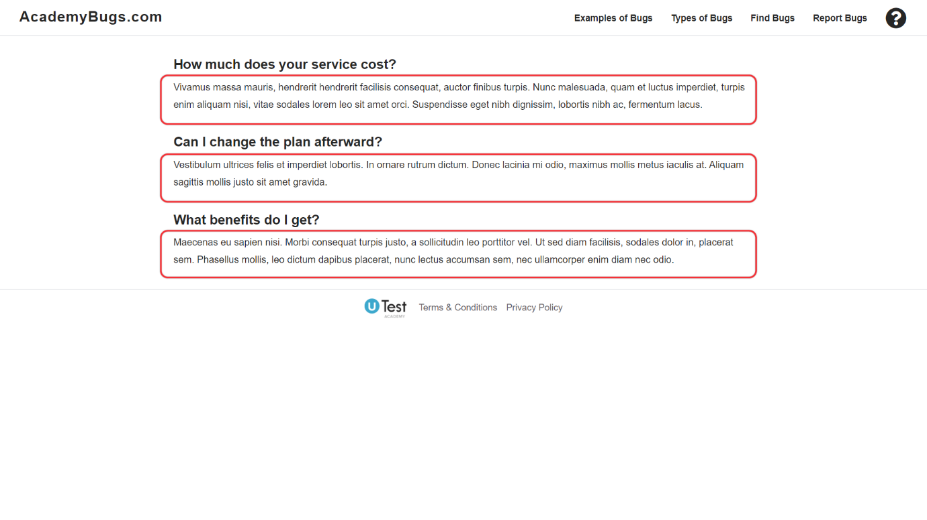

**4. Performance**

Problematic slowness or hanging, sluggish interface. Features take longer to load than they should, slow navigation in the application.

**Examples:**

* Application reacts slowly when navigating throughout features
* Application or pages take too long to load
* Application freezes or becomes unresponsive for more than 10 seconds

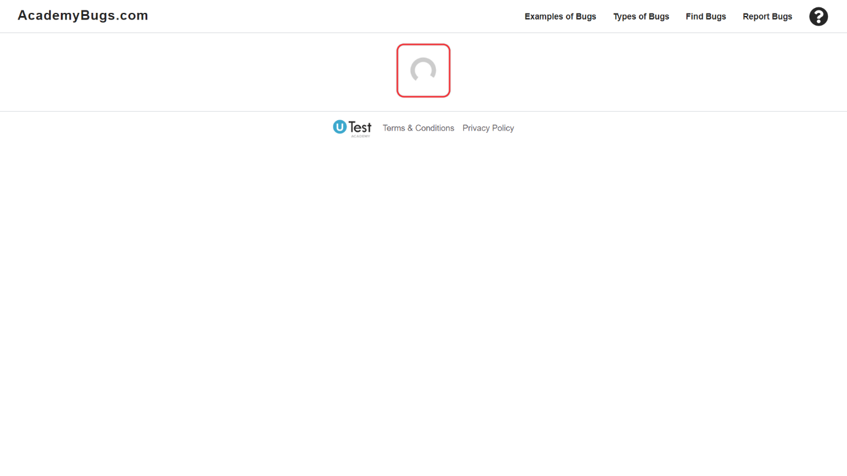

**5. Crash**

Application quits or closes unexpectedly while using the features.

**Examples:**

* Web - page hangs and doesn’t respond, ultimately resulting with an error, or the browser closes
* Computer - application freezes the device, hangs for a long time or closes abruptly
* Mobile - applications close abruptly with an error

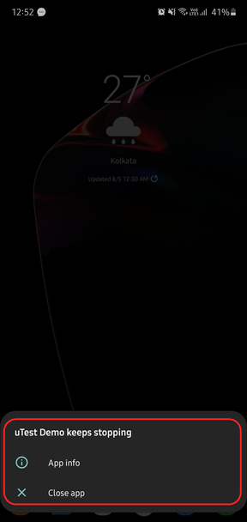

**What is an issue report?**

An issue report is a report containing all the required information to understand, reproduce, and fix the issue.

You must always write a well-written issue report with all the required information.

**What is a Valid Bug (Issue)?**

[**https://www.youtube.com/watch?v=tTb7X2XeUZE**](https://www.youtube.com/watch?v=tTb7X2XeUZE)

**What is a valid issue?**

Issues that fulfill all cycle requirements are only considered valid. So, every issue you discover while testing is not supposed to be valid, you must consider the requirements and only report valid issues.

**How to make sure an issue is valid**

Let’s see the factors that determine whether an issue is valid or not.

**Working as Designed**

You may think you found an issue, but actually, it isn’t an issue and is simply how the system works, these are invalid issues. At uTest, we classify such issues as Working as Designed or WAD. Understanding the product first will help you avoid such issues. But do not worry too much about WAD as rejections due to this reason do not have any effect on your ratings. WAD issues can be tricky at times, even for experienced testers. Just use your best judgment. Let’s make it more clear by looking at some examples:

* **Example 1:** You are testing a website, and you didn’t see any sign-out button on the site, but as per instructions, a sign-out button should be present on the homepage, so you reported it. But the sign out button is hidden inside a dropdown menu, which you didn’t check. So it turns out to be a WAD issue. It can be good feedback to make the sign-out button easily accessible, but it is not an issue as the developers intentionally put the sign-out button inside the dropdown menu.
* **Example 2:** You are testing a shopping website, and you sorted items using price, low to high. There are two prices of a product, actual price, and discounted price. The site is sorting items using actual price not by discounted price, so at first, you may think the sorting is incorrect and report an issue. So the reported issue is invalid as the sorting is working as designed. Sorting the items using a discounted price is a good suggestion, but it is not an issue.

**Out of Scope areas**

The issue you are reporting must be in the scope of the cycle. Every cycle will have details about in scope and out of scope areas in the overview. Any issue reported outside of the scope is invalid.

* **Example:** In the ‘Out Of Scope’ section of the overview, it is explicitly stated that the ‘Help page’ is out of scope. So, if you report any issue within the help page, it will be rejected.

**Do not report criteria**

Depending on the test cycle, it may have requirements on what type of issues testers can submit. Information regarding this will also be stated in the ‘Out Of Scope’ section of the overview.

* **Example:** In the ‘Out Of Scope’ section, it is stated that visual issue & localization issues are not in scope. So, if you report any visual & localization issues, it will be rejected.

**Duplicate**

Any issue can be reported only once by a tester, reporting the same issue again will result in a rejection. Always review the existing reported issues before reporting a new one.

**Known Issues**

Known issues are the issues that are already known to the customer, and reporting the same issue again will be considered as a duplicate. Depending on the test cycle, it may or may not have any known issues list. You can find the known issues in the overview of the cycle or in the issues tab. So if a cycle has known issues, it is important to review them before reporting a new one.

**Following Instructions**

You must always follow instructions while testing and reporting an issue. If you do not follow any instructions, even though you reported a valid issue, it can be rejected as DNFI (Did not follow instructions).

* **Example:** Reporting an unclear issue report, reporting placeholder issues, not using uTest VPN when it should be used, etc.

**Note:** These are the main requirements you need to fulfill to report a valid issue, depending on the cycle, there may be additional requirements, so you must read the overview and follow the instructions.

**When is an Issue Not an Issue?**

**Working as Designed? Or Not Designed as It Should Work?**

One of the most challenging aspects for new testers is understanding the fine line between a valid issue and helpful feedback. Even experienced testers occasionally struggle with this distinction. What one developer might acknowledge as a flaw, another may dismiss as "WAD" – "works as designed."

As a rule, an issue is "something not working as designed." However, many new testers fall into the trap of reporting "not designed as it should work." The former is a clear defect; the latter often falls into the realm of feedback. While these concepts may sound similar, the difference is crucial. One describes something broken, while the other points to something that could be improved. Even further removed from a true issue is reporting "not designed how I like it." While your insights might be valuable, understanding the scope of the test cycle will help you determine what type of input is appropriate.

**Examples**

Let’s examine three issues found on the same page to understand these distinctions:

1. Clear Issue: Not Working as Designed
   * The back button on a webpage does not function as expected.
   * This is a valid issue because the intended function is broken. Such findings typically lead to approval and payment.
2. Gray Area: Poor Design but Functional
   * A search engine fails to account for minor typographical errors (e.g., "Bryan" instead of "Bryant").
   * While the design could be improved, the search engine works as specified. Whether this is approved depends on whether the client values this type of feedback.
3. Works as Designed: No Functional Impact
   * Submitting an empty search field reloads the page without an error message.
   * This behavior is common across major search engines and does not disrupt user interaction. It is more of a "user expectation" issue rather than a functional defect.

**Understanding the Customer's Priorities**

Each test cycle comes with specific instructions outlining what the client values. Always align your reports with the stated goals. Consider this advice:

*Please make sure that all the links and functionality of the website are working by testing as a regular user. Let us know if anything interferes with the user experience on the site.*

Given these instructions, let's analyze two tester submissions:

**1. Excessive Character Input in a Form**

* While the tester found that entering hundreds of characters did not break the page, this discovery does not align with "testing as a regular user." Such "negative testing" findings are usually rejected unless they cause a significant malfunction.

**2. Broken Navigation Link**

* If a key link like "Back to NBA.com" does not function, it directly interferes with user experience. This is a clear defect that should be approved.

Understanding the customer’s priorities is essential. While some cycles encourage testers to push limits and break the product, most focus on real-world user experiences and practical issues.

**The "Once Upon a Time" Issue**

Sometimes, an issue surfaces but cannot be reproduced consistently. These "once upon a time" issues are rarely prioritized unless they cause a critical failure. If you encounter an issue that occurs only once, take the following steps before submitting:

* Clear your browser cache.
* Restart your browser.
* Reproduce the issue.

If the problem persists and has a tangible negative impact, report it. Otherwise, it is likely to be dismissed as an isolated occurrence.

**Key Questions to Ask Yourself**

When uncertain whether to report something, use these guiding questions:

1. Is something not working as designed?
2. Did the client highlight this as a key area to test?
3. Does it interfere with the user's ability to use the site?
4. Can you reproduce the issue consistently?
5. If only once, does it cause a significant negative outcome?
6. Does it reduce user enjoyment or satisfaction?
7. Is the implementation unconventional or inconsistent?
8. Is there a more optimal way to achieve the function?
9. Are you reporting based on personal preference rather than a functional flaw?

The closer your finding is to the top of this list, the more likely it is a valid issue. Findings closer to the bottom often fall into the category of feedback.

**Final Thoughts**

By aligning your reports with these principles, you will increase your approval rates while reducing rejections. Most cycles have a TTL, TE and customer representatives monitoring discussions, don’t hesitate to ask questions if you are unsure.

And remember: A rejection does not mean you are wrong. It simply means your finding does not align with the customer’s current priorities. By focusing on what matters most to the customer, you will become a more effective and valuable tester.

**Testing a Website or an App**

[**https://www.youtube.com/watch?v=utWL9ZztAg0**](https://www.youtube.com/watch?v=utWL9ZztAg0)

Let's discuss how to test a website or an application. We will just talk about the steps you should follow. More detailed information, like how to report a bug, how to create attachments will be discussed in the upcoming tracks.

**Read the instructions**

This is the most important part. You should always read the overview and understand the instructions before starting to test. Skipping the overview and not following the instructions properly may result in your work getting rejected.

Here’s why it is important:

* Helps you understand the product being tested
* Helps you understand which kind of bugs customers are looking for
* Often overview includes information about how to access the testing site or application
* Contains information about In Scope and Out Scope sections
* Often overview includes known issues. Issues that are already known will be rejected if reported again
* Issue reporting instructions
* Any additional important information

**Understand the product**

You should have an idea of what you’re testing and what it does. It helps you understand which areas and features of the product are important and should be tested first. Also, in the overview section, you will find details on focus areas. Once you have an understanding of the product, you’re ready to start testing.

**Use the product**

Open the site or install the app and start using it. As you learned in the previous courses, testing is evaluating a product to find what is and isn’t working. Use it as real users will do, test all the features and functionalities and bugs will start to appear. As a new tester, you may find it difficult to find bugs but not lose hope and keep on testing.

**Report the bug**

Once you find a bug, it’s time to report it. But first, make sure the bug is valid. In the previous course we already discussed this.  
Now once you’re confident that the bug is valid, it’s time to report it. Create all the attachments required (we will teach how in the next tracks), fill out the issue report form with all details and report the bug.

**Respond to requests**

You’re not finished by reporting the bug. TTL, TE, or Customer may ask for more information. You must respond to their messages and provide the information requested on time.

**Exploratory Testing**

**The ‘Traditional’ Approach to Testing**

Before we look at Exploratory Testing (ET), it might help if we first talk about a different, more traditional approach to testing so we can use that as a reference point to make some comparisons.

Scripted Testing (ST) is a two-step approach to testing:

* The tests are planned, designed and written.
* The tests are executed.

These two activities are done independently of each other and in many cases, the person who writes the tests is different than the person who executes them.

Generally, the tester executing the tests has some knowledge of the product, or the tests include the information needed to execute them. This is important because without that knowledge or information, the tester might not be able to execute the test or interpret its results.

**What is Exploratory Testing?**

Exploratory Testing (ET) is a simultaneous activity of learning, test design and test execution. In other words, the tester is designing his or her tests and executing them at the same time. As an exploratory tester, your next action (the next test) is influenced by your previous actions, your observations of the product’s behavior, and your own thought process.

The key aspect of Exploratory Testing is not the test technique being used or the product being tested, but the skills and experience of individual testers.

Exploratory Testing also assumes that a significant portion of the testing will be spent learning about the product. As you explore, you become more aware of how the product functions and its expected behavior. You can use that knowledge to design new and better tests. It also helps improve the analysis of the test’s results.

**Note:** You will only be paid for your approved work, not the time you spend testing.

**How to Do Exploratory Testing?**

When the app for testing is ready, an exploratory tester would do something like this:

* Get a notebook (or a digital word processor) to take notes as you go.
* Explore the app as if you just downloaded it and want to use it yourself. Don’t worry about finding any bugs right now. You may stumble on them, but this is really just getting used to the app. Jot down anything you find that you want to explore further later.
* Once you get a feel for the app, start going back to the areas that interested you and you thought might be a place of vulnerability in the app. This knowledge about vulnerability is going to come with experience. Don’t worry if you don’t have any experience yet because you are about to get some.
* One by one, work through each area you’ve earlier identified, exploring every function in that area. Think of what a real user might do. Come up with some use cases or scenarios and execute those. Then think of variations and execute those. Use the results of your tests to help you come up with new ideas.
* Focus on one bug at a time, but always be on the lookout for hints of other bugs or suspicious areas. In your notebook, quickly make a note of these areas and how to get back to them and explore later. You could very well end up with 4 or 5 bugs just from investigating the initial bug.
* Once you’ve exhausted that area or function of the app, move on to your next point of interest. As you repeat this process, remember what you’ve learned so far and use that information to influence your tests.

As you can see from this narrative, you are simultaneously learning, designing tests, and executing the tests. These are the core pieces of ET. Understand this and you’re on your way to becoming an exploratory tester.

**Pros and Cons of Scripted Testing**

**Pros:**

* Careful thinking about the design of each test
* Review by other stakeholders
* Reusability
* Known comprehensiveness of the set of tests
* The percentage of the completed tests can be calculated as a metric if the set is considered comprehensive
* Well-suited for testing high-risk applications such as financial applications
* Well-suited for automation
* Can be helpful to those testers who do not have enough domain knowledge to test the system on their own

**Cons:**

* Fewer bugs are found
* The scripted approach means the test stays the same, even though the requirements / specifications are almost certain to change as the program evolves
* Focuses on limited areas constrained by the script
* Substantial preparation and time is needed to devise test plans (covers all major activities) and test cases (covers a particular scenario)

**Pros and Cons of Exploratory Testing**

**Pros:**

* Well-suited for the agile development approach as it is more adaptable to changes
* Less preparation is needed to devise test cases
* Ideal for situations when the product owner has limited time to test
* Critical bugs are found early as the tester explores the major functionalities first
* Helpful in areas where automation may not be effective
* Testers’ creativity, experience and skill have a great impact on testing outcome
* The explorer can do any combination of learning, designing, executing and interpreting at any time
* Enhances testers' skills in learning and taking new notes that will increase the scope of the testing process in future cycles and projects

**Cons:**

* Cannot be automated, only some aspects can
* There is no strict documentation for reference
* Less time to be familiar with the new app, especially for new testers
* Difficult to reproduce the bug, as sometimes testers are not able to keep track of what they have tested
* The time spent testing will not be paid, but you will be paid only for your approved work

**Misconceptions About Exploratory Testing**

**Exploratory Testing is Unprepared**

Not scripting doesn't mean unprepared. It's about enabling choice, not constraining it. There can be detailed documentation in exploratory testing.

**Test Cases are not Used in Exploratory Testing**

Testers using exploratory approach can use test cases to assist their testing activity. Lack or presence of scripts does not define exploratory testing. Any testing activity where the learning from the previous test influences the next test is exploratory testing to some degree.

**Only an Experienced Tester Can Do Exploratory Testing**

The experience of a tester is not the pre-requisite for exploratory testing. Any tester who is willing to learn and practice the skill of exploration and investigation can perform exploratory testing. Explaining and defending the testing activities is important in exploratory testing.

**Test Case Execution**

**Introduction**

The software testing phase in the software development life cycle is one of the most crucial components of the quality management process. It requires that testing begin as early as possible in the development process and that it continue all the way through implementation. The earlier bugs are found in development, the lower the risk and cost a company has to absorb in deploying their software.

Proper test case execution is essential in ensuring the success of any testing project; therefore, focusing on best testing practices helps minimize rework and reduce time to market for software delivery. As such, a trained, knowledgeable, informed, and engaged tester provides the best defense against quality and software mishaps, bringing value and operational excellence to a customer's product.

A common challenge for customers is to ensure appropriate breadth and depth in the testing of their software applications. Testing breadth speaks to coverage across the application. For example, are the new features properly working, is the uninstall executable removing the correct files from the user's device, and are actions performed via the mobile application syncing with the web application? Testing depth speaks to exhaustive testing of a particular feature. For example, is the checkout form being tested for potential timing out conditions, pressing the back button on the mobile device, and are there issues with entering an online promo code after adding a product to the user's shopping cart?

Since every customer utilizes a different approach or methodology toward testing, you will also see different types and styles of test case documentation. Testers must not modify a customer's test case, but any columns or steps must be completed completely and accurately since you do not know how the customer will compile and analyze the data. Also, it is essential to be familiar with the product as much as possible before executing the test case since there are different types of testing that can be performed.

Review all related material provided by the customer, complete any required tutorials, and ensure that you clearly understand the testing requirements. The more a tester understands what is expected, the better they will be able to execute the test case according to the customer's specifications and, in the process, identify potential areas for testing that may not have been included in the test case. This prepares the tester for improved ad hoc or exploratory testing. However, before investing time and effort into areas outside of the provided test cases, it's crucial to understand what is in scope and out of scope. Typically, this information is provided in the cycle overview, slot instructions, or test case instructions. In the unlikely event that you do not find the information you seek or if you have a doubt, please feel free to contact the TTL or TE of the cycle for clarification.

**Test Case Definition**

Every test case has a series of steps to help the customer determine whether a product is working correctly. Generally, most test cases contain several fields that either inform or require testers to complete, such as

* Step Description
* Steps
* Expected Result
* Actual Result
* Status
* Observations/Comments columns
* Bug ID is another field you may come across, typically at the end of the table or for each test case step

If the test case is created on the uTest platform, it contains steps, expected results, Status, and attachments. For more information, review the [What is a Test Case?](https://www.utest.com/academy/tracks/33/courses/test-case) course.

**Sample Test Case**

**Test Case Testing Approach and Tips:**

When a tester executes test cases, they should follow instructions carefully, as every test case is unique in requirements and formatting. Typically, test case submissions come with guaranteed compensation. As a tester, test cases may be more appealing than pure exploratory testing.  
The key to a successful test is to follow the test case closely and follow all the steps listed. TTLs, TEs, and Customers review all test cases and will be able to identify test case results that are not completed honestly, accurately, and thoroughly.

**Preconditions:**

When you start executing the test case. First, make sure all the preconditions are fulfilled if there are any. If this precondition is not fulfilled, then you will not be able to execute the test case correctly.

**Completing steps in order:**

Test cases steps should be run in the order specified. Each test case step normally has dependencies on the previous steps. For example, step 2 requires you to execute step 1 first.

**Verification:**

Verify each step of the test case very carefully. When testers execute a test case, they should ensure that each verification point mentioned in the test case is verified correctly as per the expected results.

**Status:**

If the actual result matches the expected result of the test case, then the Status should be updated to PASS, and if it is not, then the Status should be updated to FAIL.

* **PASS**: If the Status for a particular step is PASS, then move to the next step.
* **FAIL**: If the Status for a particular step is FAIL, verify if this bug has already been reported or if it is known issue. If not, report it. After you have reported the bug, continue completing the subsequent steps in the test case. If subsequent steps depend on the failed step and there are no workarounds, ask for guidance from the TTL or TE of the cycle.

**Observations:**

Observations are essential in the test case. Here the tester can highlight the insight you gathered while completing a particular step. The information provided serves to help the customer troubleshoot an issue or better understand if there is any potential confusion for end users. Observations can be provided for both PASS and FAIL steps.

**Thorough completion of the Test Case:**

* Make sure to fill in all steps when executing the test case.
* If, for whatever reason, you cannot complete a certain step, contact the TTL or the TE of the cycle for assistance.
* Pay close attention when executing every step of the test case.

**Bugs Reporting:**

As mentioned above, under a failed step, if you encounter a bug, first try to reproduce it and understand the root cause. Then verify if that particular bug has already been reported in the cycle. Duplicate bugs should not be reported, so make sure to review the previously submitted bugs and the known issues list, if there are any, before you submit your bug to avoid getting a rejection. When submitting a bug report, remember to include step-by-step details about what the tester did for easy reproduction, including the required attachments.

Each failed step should have a bug attached to it. Enter the Bug ID in the Bug ID column; For example, Bug ID #451178 for step 2. Refrain from assuming that the person reviewing your observations/comments or reporting is familiar with the product.

It is best practice to provide observations and comments as though your audience is not a user of the application you are testing. This ensures that any recipient can reproduce what you have experienced and assist in getting your bugs approved. Remember, clear communication on observations and steps taken when experiencing a bug is key to resolving issues found during testing. Refer to [The Bug Reports](https://www.utest.com/academy/tracks/17)course for information on bug reporting.

*Root cause: This analysis method requires additional instructions on how to do it effectively and determine if what the user is experiencing is a root cause of an issue.*

**Test Case File Name:**

Testers might be required to save test case files with information that helps identify the test case and who completed it in some cycles. A good practice is to retain the customer's name for the test case or the test case name and add your operating system and browser to the test case name, for example, uTest\_Registration\_macOS\_Safari.  
Additionally, if multiple testers are participating in a test cycle with the same OS and Browser, adding each tester's last name may be helpful. Finally, be sure to follow each Test Cycle's instructions on how to complete and execute test cases.

**Exploratory Testing:**

Exploratory tests may be run along with test cases. Therefore, you can perform exploratory testing when completing/executing test cases. In this case, ensure you conduct adequate exploratory testing by testing on depth against the in scope focus areas or in scope areas. You will typically be required to complete the test case before performing extensive exploratory testing. Thus, please complete and submit the test case before further exploratory testing. Learn more about Exploratory in the [Exploratory Testing](https://www.utest.com/academy/tracks/34/courses/exploratory-testing)course.

**Note**: This course specifically addresses how to complete test cases and includes a few scenarios that are often included in test cases. Also, this course only serves as background information, so please follow the instructions on completing and executing test cases for every Test Cycle.

**Best Practices**

**Always read the overview**

We already discussed it but again always read the overview before starting to test. It is extremely important. Read the overview many times and make sure you understand everything. If something is confusing or you need to know something, reach out to TTL (Test team lead) via test cycle chat.

**Preparing your system before testing**

It is a good practice to prepare your system before testing. Like:

* Disabling any browser extensions, like ad-blockers
* Clearing browser cookies and cache
* Disabling any VPNs if turned on
* Closing unnecessary apps or browser tabs

**Use the product like a real user**

You should always try to use the testing product as a real user and not as a bug hunter. Doing so will help you find bugs which are most likely to be faced by a real user. Hence you will find more valuable bugs.

**Reproducing a bug many times**

Once you find a bug do not rush to report it, instead reproduce it multiple times to be sure the bug is reproducible more than once. If not specifically asked, non-reproducible bugs are likely to be rejected.

**Reporting a high-quality bug**

Reporting a quality bug is very important. Avoid things like:

* Spelling & grammar mistakes
* Never report placeholder issues, this is against the [uTest Guidelines](https://www.utest.com/utest-guidelines" \t "_blank)
* Not providing enough information or attachments

**Reproducing other tester issues**

Reproducing already reported bugs or doing +1 with attachments are beneficial for you and also for customers.

* Doing +1 helps you understand which bugs are already reported
* Doing +1 boosts your rating
* Helps customers understand which issues are reproducible on other devices

Learn more about +1 feature [here](https://www.utest.com/academy/tracks/17/courses/confirm-issue-report-feature).

**Be Professional**

Always try to be professional while working at uTest. Here are some important tips:

* Always read everything carefully and understand and then take action
* Do not make noise in chat. Means do not ask the same questions, already asked questions or irrelevant questions
* When replying to messages, disputing issues or emailing any team member, always write professionally
* Talk to your fellow testers respectfully

**Best Practices**

**Always read the overview**

We already discussed it but again always read the overview before starting to test. It is extremely important. Read the overview many times and make sure you understand everything. If something is confusing or you need to know something, reach out to TTL (Test team lead) via test cycle chat.

**Preparing your system before testing**

It is a good practice to prepare your system before testing. Like:

* Disabling any browser extensions, like ad-blockers
* Clearing browser cookies and cache
* Disabling any VPNs if turned on
* Closing unnecessary apps or browser tabs

**Use the product like a real user**

You should always try to use the testing product as a real user and not as a bug hunter. Doing so will help you find bugs which are most likely to be faced by a real user. Hence you will find more valuable bugs.

**Reproducing a bug many times**

Once you find a bug do not rush to report it, instead reproduce it multiple times to be sure the bug is reproducible more than once. If not specifically asked, non-reproducible bugs are likely to be rejected.

**Reporting a high-quality bug**

Reporting a quality bug is very important. Avoid things like:

* Spelling & grammar mistakes
* Never report placeholder issues, this is against the [uTest Guidelines](https://www.utest.com/utest-guidelines" \t "_blank)
* Not providing enough information or attachments

**Reproducing other tester issues**

Reproducing already reported bugs or doing +1 with attachments are beneficial for you and also for customers.

* Doing +1 helps you understand which bugs are already reported
* Doing +1 boosts your rating
* Helps customers understand which issues are reproducible on other devices

Learn more about +1 feature [here](https://www.utest.com/academy/tracks/17/courses/confirm-issue-report-feature).

**Be Professional**

Always try to be professional while working at uTest. Here are some important tips:

* Always read everything carefully and understand and then take action
* Do not make noise in chat. Means do not ask the same questions, already asked questions or irrelevant questions
* When replying to messages, disputing issues or emailing any team member, always write professionally
* Talk to your fellow testers respectfully

Complete the task for the experience for the tester carrier

**How to use the site**

[AcademyBugs.com](https://www.academybugs.com/) is designed to help new testers to understand what bugs are and how to find them in a simple and effective way.

**Sections of the site**

**Examples of Bugs**

The Examples of Bugs page contains 6 tiles, each tile will direct you to an example of a bug. Click on a tile to reveal the bug.



**Types of Bugs**

The Types of Bugs page contains 5 tiles, each tile will direct you to an example of a different type of bug. Click on a tile to reveal the bug.



**Find Bugs**

This page contains a practice site which has 25 bugs planted inside of it. Thoroughly explore the pages and try to find 20 of the bugs. If you want to practice more, you can find all 25.



**Report Bugs**

The Report Bugs page contains 5 tabs, within each tab you will practice creating high quality bug reports.



**Tutorial**

For your convenience we have added a Tutorial. If you feel the website is difficult to navigate, just click on the ? icon in the top right corner. The Tutorial will guide you through the various features of the website.



**What to do on the site**

**Understand bugs and bug types**

1. Open the [AcademyBugs.com](https://www.academybugs.com/) website.
2. Explore the **Examples of Bugs** and **Types of Bugs** sections.
3. Understand what bugs are and the different types of bugs by looking at the examples.

**Find bugs on your own**

1. Once you understand what bugs are and the different bug types, navigate to the **Find Bugs** section.
2. Explore the Find Bugs page and locate at least **20 hidden bugs**.
3. Attempt the quiz once you have found at least 20 bugs.

**Create bug reports**

1. Navigate to the **Report Bugs** page.
2. Create the first bug report by selecting the correct choices.
3. Once done click on the **Submit Issue** button to see your results.
4. Move on to the next one and complete creating all 5 bug reports.